Study on Launch Load Experiment of S-PC Shear Connector

Jian Xu¹, Liang Tang², Xiaoyan Zhang³, Hong Xiang⁴, Zhixiang Zhou^{5,*}
School of Civil Engineering, Chongqing Jiaotong University, China
*Corresponding author
E-mail:
¹54923822@qq.com,²cqutang@qq.com,³cquz@qq.com,⁴842931854@qq.com,⁵zhixiangzhou@cquc.edu.cn

Abstract
The S-PC (Steel Box-Prefabricated Concrete Deck) shear connector which combines the bridge deck with steel box girder by the way of watering concrete rear is proposed herein in allusion to the features of the construction of Steel Box-Prestressed Concrete composite large-span rigid frame bridge. Several specimens' push-out test are designed and accomplished and the calculation of cross section stress simulation is developed using the finite element software.

Keywords: Shear connector; S-PC shear connector; Composite bridge; Calculation

1. Introduction
Steel-concrete composite structure is a new structure which flourished on the basis of steel structure and reinforced concrete structure. It combines steel and concrete through shear connector to resist sliding and separating under several of loads, which makes the two parts work together. With a wide application of composite structure, shear connector receives more attention. The feature of S-PC shear connector，mentioned in this article ,is that waters concrete rear to make the combination of shear connectors and steel box into work. It gives S-PC shear connector a plenty of advantages. It can use prefabricated bridge deck, separately prestress the bridge deck, and prevent cracking in negative moment region and so on. It is an applicable rigid shear connector for the fabricated steel box-prestressed concrete composite continuous rigid frame bridge. In the previous studies [1-4], researchers focused on shear connector itself and the strength of the concrete whether the flexible shear connector with stud or the rigid shear connector with channel section, and few people research its performance affected by watering concrete rear. In order to provide reliable data for the design of SB-PC combined continuous rigid frame bridge we need to conduct the thorough research to the S-PC shear connector.

2. Experiment and FEM simulation analysis
For the study of the features and working performance of S-PC shear connector, in this article we designed 5 specimens as shown in Fig. 1, and established the model of them with the FEM software ABAQUS. By the comparison of the measured value and FEM calculated results as in Fig. 2, we can see that they agree well in the elastic session and FEM has a relatively good precise and reliability in the elastic session.

3. Cross-section stress distribution of concrete plate
As is shown in Fig. 3, the stress distribution of cross section is determined by the XoY coordinate in cross section C that is 40mm to bearing surface of shear connector.
Fig. 4 shows the maximum and minimum principal stress distribution of concrete plate in cross section C when loads are 205kN (0.33).
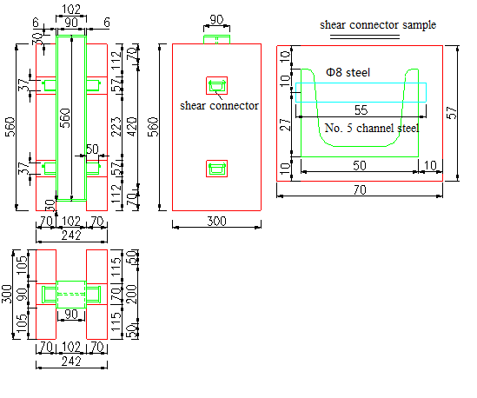
Fig. 1. Form and structure of the Specimen
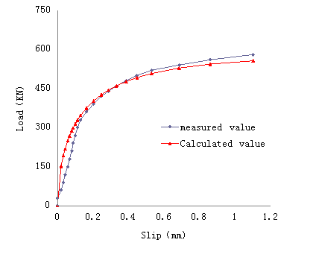
Fig. 2. calculated value and measured value

Fig. 3. Stress value position

It can be found that the minimum principal stress was mainly distributed in the core compression zone below shear connector, out of compression zone, compressive stress spread rapidly and became small. The position of maximum principal stress namely tensile stress was corresponding to the splayed inclined crack position on concrete slab.

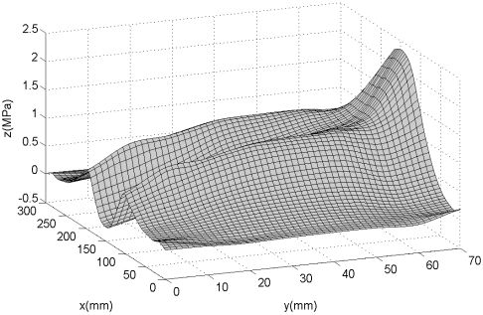  Fig. 4(a). The maximum principal stress of C cross-section (205kN) | 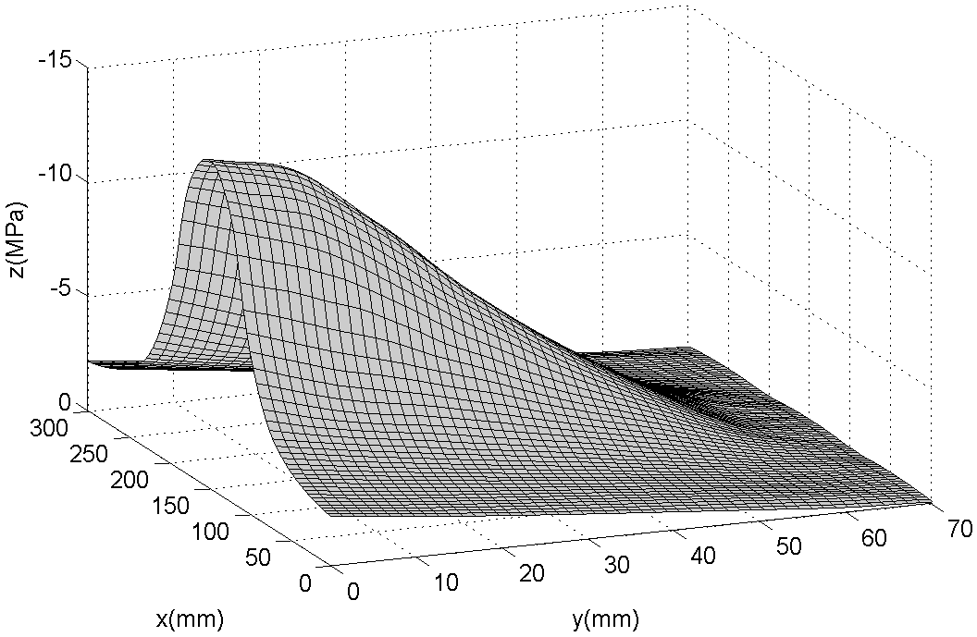  Fig. 4(b). The minimum principal stress of C cross-section (205kN)

4. Shear stress distribution
Mises stress distribution along both the x and y directions (shown in Fig. 4(a) and Fig. 4(b), x and y are the center line and edge of bearing surface respectively) are shown in Fig. 5.

Fig. 5. The position of stress value

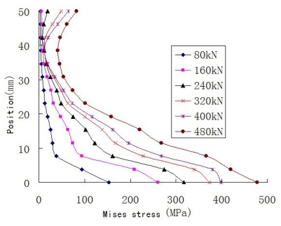  Fig. 6(a). The mises stress in the center of bearing surface | 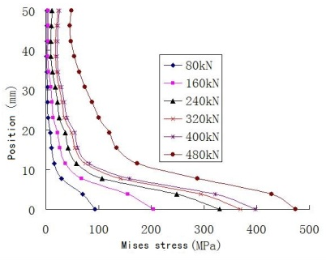  Fig. 6(b). The mises stress on the edge of bearing surface

It can be seen from Fig. 6, the S-PC shear connector is a rigid shear connector, stress distribution along center line and edge of bearing surface is slightly different, stress in the root is large and it decreased sharply with the increase of distance to root, so that the shear stress is mainly concentrated in root position of shear connector. As the load increases, the shear stress increases, the integral curve moves to the right. It can be found that an inflection is in the upper edge stress curve, when load is small, the shear connector is acting like cantilever beam that stress is large in the root and small in the end and results in no inflection. However, when load is large, shear connector rotates a litter compared with welded steel members, results in a reduction of constraints to inside concrete in the end of shear connector, thus increases the force of shear connector end, forms a shear and bending interaction and results the inflection of stress curve. Mises stress distribution along both the x and y directions (shown in Fig. 7, x and y are the root of bearing surface and the root of side surface, respectively) are shown in Fig. 8 and Fig. 9.

Fig. 7. The taking value position of stress

It can be seen from the Fig.8 and Fig.9, when load is small, stress that close to shear connector edges is large because those edges are the interface of concrete and steel, besides, concrete inside of shear connector has little influence on this region. With the increase of load, root of shear connector begins to yield, and stress in the root eventually becomes the same.

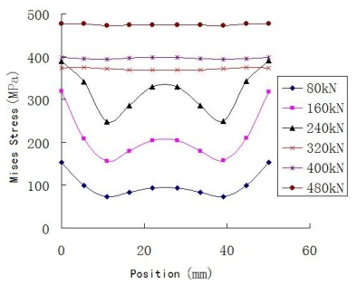  Fig. 8. The mises stress in the root of bearing surface | 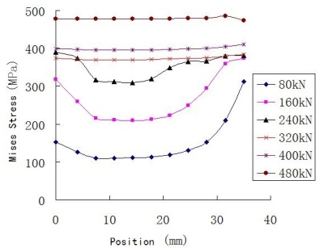  Fig. 9. The mises stress in the root of side face

5. Bearing capacity calculation
There are three main failure models of the S-PC shear connector, <1> Concrete failure, <2> Shear failure in the root of shear connector, <3> Shear connector failure by bending. The damage should be avoided.
(1) Concrete failure
Because of the confinement of stirrups carried by the concrete under shear connector and the concrete underside is in the core compression, an improvement coefficient of concrete strength must be multiplied when calculating the ultimate load of shear connector, not just use the bearing area of shear connector multiplied by concrete strength. The following calculation of improvement coefficient divided into two with one improvement coefficient k₁ is represented by concrete slab width and another improvement coefficient k₂ is represented by concrete thickness, the whole improvement coefficient k is represented by k₁ multiply k₂. So the calculation formula for ultimate load of shear connector expressed as follows:
$$Q_{u1}=Af_{ck}k=bhf_{ck}k_{1}k_{2}$$ | (1)
The determination of the coefficient k₁ along slab width direction. When the load to the limit load , according to the result of finite element calculation , take the stress distribution near the pressure-bearing surface of shear connector directly below the center , namely, compressive stress distribution along the concrete slab width direction , its stress distribution curve is Symmetrical hat , as shown in fig.10 . Area surrounded by the actual stress distribution curve, according to the principle of equal area equivalent to a rectangle, the height of the rectangle for the axial compressive strength of concrete is f_{ck}, k₁b as the rectangle's width. In this way, we get k₁ as the coefficient of strength increase of shear connector along the width. Similarly, the S-PC shear connector along height direction namely k₂ can be obtained.
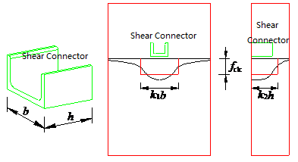
Fig. 10. Equivalent figure of dimensions

(2) Shear failure in the root of shear connector
The finite element analysis under two kinds of situations in Fig.11 (a) and (b), shear force is equal to the resultant force of uniformly distributed load, which is about 0.7Q_{U}; get the shear force and bending moment of the roots of shear connector. We can find that under the constraint of a concrete shear connector root bending moment is small , its value is 4.423 , not under the constraint of a concrete shear connector moment to 2.36x10³, It can be seen that when the shear stiffness , mutual constraints made by concrete slab and steel beam result in shear connector nearly completely shear state.

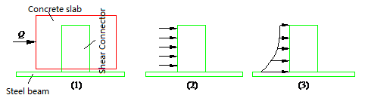
Fig. 11. Force diagram of shear connector

As a result, because shear dominant the stress of shear connector with small stiffness, therefore, in the preliminary design, the shear strength of steel $τ_{b}$ and the shear area $S$ as the product of bearing capacity, that is:
$$Q_{u2}=τ_{b}∙S$$ | (2)
Accordingly, comprehensive analysis of the two types, get the bearing capacity of the shear connector is:
$$Q_{u}=min⁡\left\{Q_{u1},Q_{u2}\right\}$$ | (3)

6. Conclusions
Using general finite element software ABAQUS analysis results coincide well with the test results, based on the finite element analysis results, which reveals the transfer mechanism of the S - PC shear connector and the stress distribution of different position and direction, and laid the foundation of research and application for this after pouring concrete S-PC shear connector.

Acknowledgments
Supported by the national natural science fund project（50578168); Application development projects in Chongqing (cstc2013yykfB0123); Open fund projects of bridge and tunnel engineering state key laboratory breeding base of Chongqing Jiaotong University

References
- Nie Jian-guo, Fan Jian-sheng. Generalized composite structure and its development prospect.Journal of building structures, 2006(6): 1-8.
- Zhou An, Liu Qi-wei, Dai Hang etc. Shear bond prestressed concrete in the steel and concrete composite beams in the relay. Highway traffic science and technology, 2006(1): 74-76.
- Xiao Lin, Qiang Shi-zhong, Li Xiao-zhen etc. Considering the PBL shear connector mechanical properties of the perforated plate thickness. Engineering mechanics, 2012(8): 282-288,296.
- Wei Y. Loo, Pierre Quenneville, Nawawi Chouw, A numerical study of the seismic behavior of timber shear walls with slip-friction connectors, Engineering Structures, 2012(34): 233-243.
- K.F.Chung., C.K.Chan., Advanced Finite Element Modeling of Composite Beams with High Strength Materials and Deformable Shear Connectors, Procedia Engineering, 2011(14): 1114-1122.
- Xu Chang-jian, Xujian. Stiffness of stitched lamina theoretical calculation and finite element model analysis. Laboratory to explore and research, 2010(7): 23-26.
- OGUEJIOFOR E C ，H OSAIN M N． Behavior of prefab an d ri b shear connectors in com posit beams ：full size test．Canadian Journal of Civil Engineering，1992 ，19 (2 ) ：224-235．
- VELDANA M R，HOSAIN M U．Behavior of pefoband rib shear connectors： push·out test． Canadian Journal of Civil Engineering，1992, 19 (1)：1-10．
- OGUEJIOFOR E C，HOSAIN M N．A parametric study of pefoband rib shear connectors．Canadian Journal of Civil Engineering ，1994 ，2 1(4 ) ：614-625 ．
- ISABEL V ，CRUZ P J S．Experimental analysis of perfobond shear connection between steel and lightweight concrete．Journal of Constructional Steel Research，2004, 60 (3-5): 465-479
- LEI Chang-long. The development and experiments of new shear connectors in steel-concrete com posited bridges. Foreign Bridges, 1999, (2)：64-68．

